**Types of Machine Learning:**

1. **Supervised/Unsupervised Learning:**
2. **Supervise Learning:**

We will train the model with the data that includes the desired solutions which are call labels. 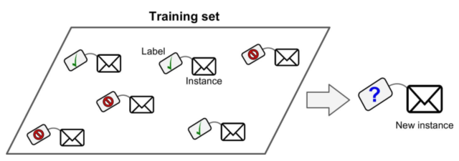

It’s usually used for classification such as spam filter or prediction such as a target numeric value such as the price of a car given a set of features.  
Notes: In machine learning, attribute is a data type, but the word feature has several meanings depending on the context. Normally, it means attribute + value.

Some important supervised learning algorithms:

* K-Nearest Neighbors
* Linear Regressions
* Logistic Regressions
* Support Vector Machine
* Decision Trees and Random Forests.
* Neural Network

1. **Unsupervised Learning:**

In unsupervised learning, training data is unlabelled. The system tries to learn without a teacher. 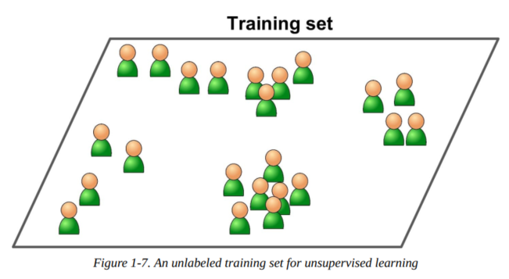

Some important unsupervised learing algorithms:

* Clustering:
  + k-Means
  + Hierarchical Cluster Analysis (HCA)
  + Expectation Maximization
* Visualization and dimensionality reduction:
  + Principal Component Analysis (PCA)
  + Kernel PCA
  + Locally-Linear Embedding (LLE)
  + t-distributed Stochastic Neighbor Embedding (t-SNE)
* Association rule learning:
  + Apriori
  + Eclat

**Visualization algorithms** are good example: we feed them a lot of complex and unlabelled data, they output 2D or 3D representation of our data that can easily be plotted.

* A related task is dimensionality reduction, in which the goal is to simplify the data without losing too much information.

Another task of unsupervised learning is: **anomaly detection**.

* Detecting unusual credit card transactions to prevent fraud, catching manufacturing defects etc. The system is train with normal instances and when it sees new instance it can tell whether it looks like a normal one or whether it is likely an anomaly.

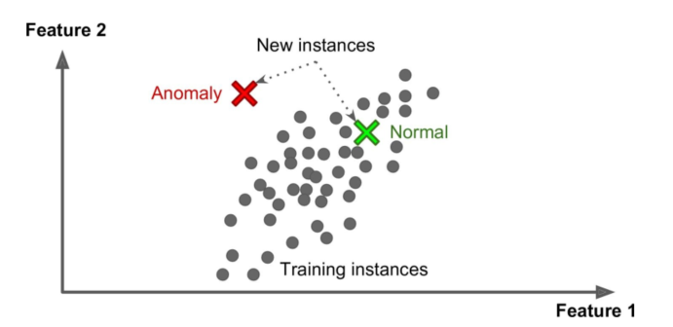

Finally, unsupervised learning can also be used for **rule learning**

* In which the goal is to dig into large amounts of data and discover interesting relations between attributes.

1. **Semisupervised Learning:**

Semisupervised can deal with partially labelled training data usually a lot of unlabelled data and a little bit of labelled data.

1. **Reinforcement Learning:**

The learning system, called an agent in this context, can observe the environment, select and perform actions and get rewards/penalties in return.

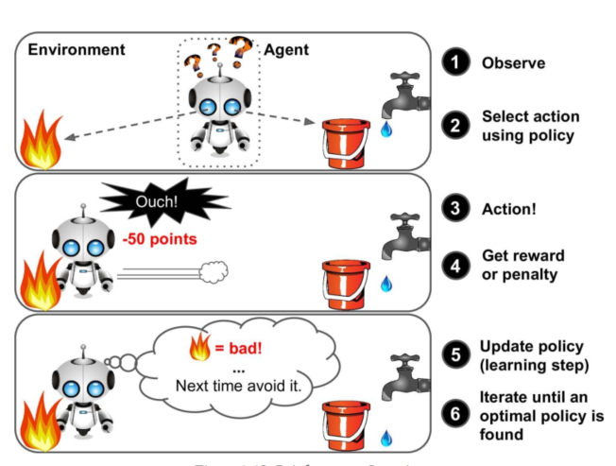

1. **Batch and online learning:**
2. **Batch Learning:**

In this algorithm, the machine is incapable of learning incrementally: it must be trained using all the available data. After the first system is trained, then it is launched into production and runs without learning anymore.

* It is called ***offline learning.***

1. **Online Learning:**

In online learning, the system is trained incrementally by feeding it data instances sequentially, either individually or by small groups called mini-batches.

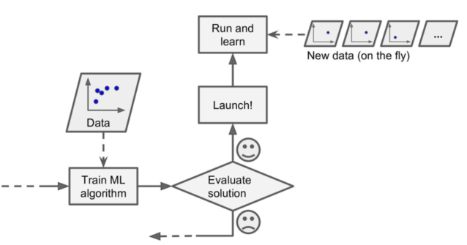

Notes: This whole process is usually done offline (not in a live system), so online learning can be a confusing name. So, think of it as incremental learning.

One important parameter of online learning systems is how fast they should adapts to changing data: this is called the **learning rate**.

1. **Instance-Based Versus Model-Based Learning:**
2. **Instance-Based Learning:**

The system learns the examples by heart, then generalizes to new cases using a similarity measure.

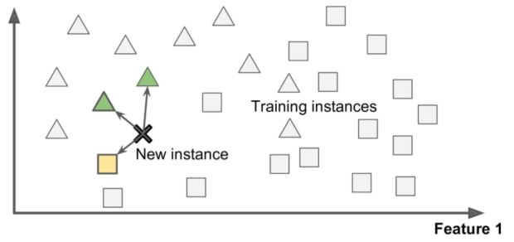

1. **Model-based learning:**

The system is built from a sets of examples then that model is used for prediction.

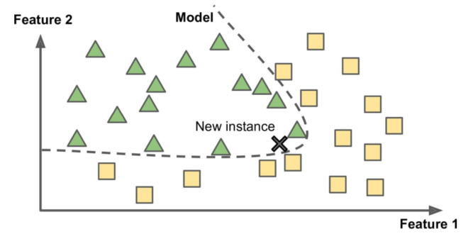

**Exercises:**

1. How would you define Machine Learning?

* Making machines better at some task by learning from data instead of having to explicitly code rules.

1. Can you name four types of problems where it shines?

* Solve problems that have no algorithmic solution
* Replace long lists of hand-tuned rules
* Build systems that adapt to fluctuating environments
* Help human learn

1. What is a labelled training dataset?

* Datasets that contain solution

1. Name 2 common types of supervises learning?

* Linear regression and classification

1. Name 2 common types of unsupervised learning?

* Clustering and visualization

1. What type of Machine Learning algorithm would you use to allow a robot to walk in various unknown terrains?

* Reinforcement learning would best suited our problem.

1. What type of algorithm would you use to segment your customers into multiple groups?

* If you don’t know how to define the groups, then you can use a clustering algorithm (unsupervised learning) to segment your customers into clusters of similar customers. However, if you know what groups you would like to have, then you can feed many examples of each group to a classification algorithm (supervised learning), and it will classify all  
  your customers into these groups.